EXERCISE – 1
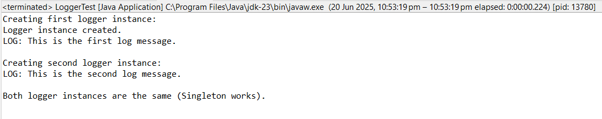

EXERCISE – 2
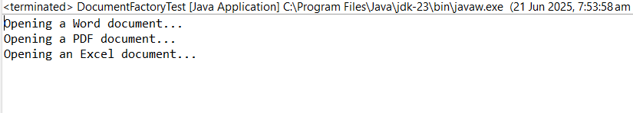

EXERCISE – 3
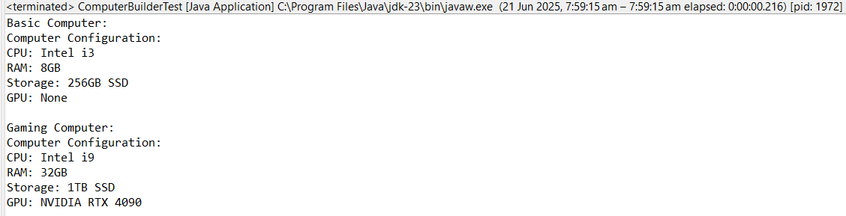
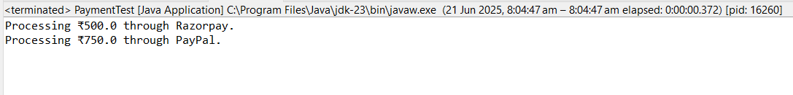
EXERCISE – 4

EXERCISE – 5

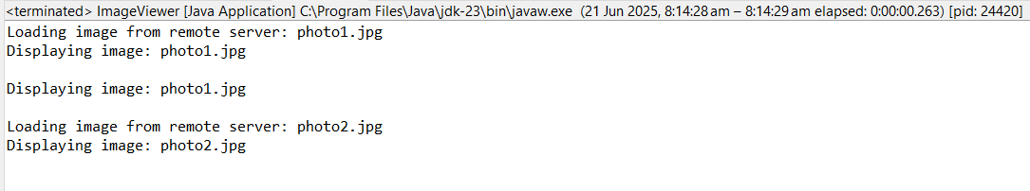
EXERCISE - 6

EXERCISE – 7
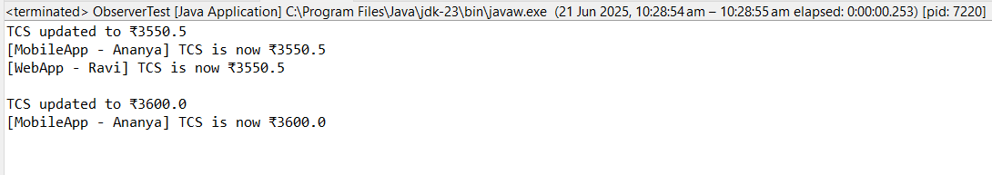
EXERCISE – 8
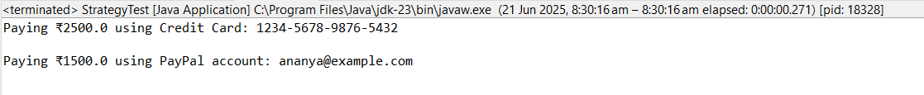

EXERCISE – 9
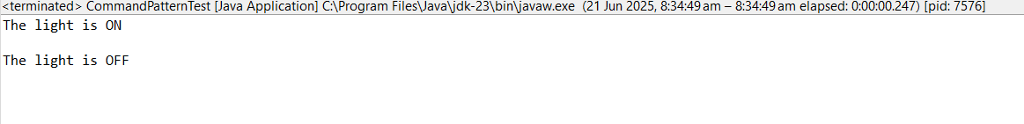

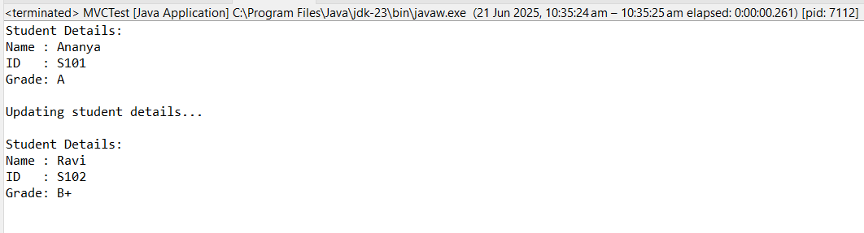
EXERCISE – 10

EXERCISE – 11

